Milestone 3: Model Development, Hyperparameter Tuning and Validation

1. Introduction
Following the successful construction of a feature-rich, machine-learning-ready dataset in Milestone 2, this milestone focused on developing predictive models for football player market value estimation. The primary objective was to systematically evaluate multiple regression algorithms, analyze their learning behavior through visual diagnostics, and identify a robust model suitable for downstream deployment.
Rather than relying on a single modeling approach, multiple models with increasing representational capacity were explored. Model performance was assessed using both numerical metrics and visualization-based validation to ensure strong generalization and stability.

2. Outlier Detection and Treatment
Given the financial nature of the target variable and related features, extensive outlier analysis was performed. Variables such as market value, transfer fees, minutes played, and cumulative performance metrics exhibited strong right-skewness with extreme values.
Outliers were identified using interquartile range (IQR) analysis and percentile-based thresholds. Rather than removing outliers—which would disproportionately affect elite players—outlier handling focused on capping and transformation strategies. Logarithmic transformations were applied to highly skewed monetary features, while extreme values were winsorized where necessary. This preserved valuable information from high-profile players while preventing model instability.Outlier analysis confirmed that engineered rolling and per-90 features significantly reduced scale imbalance compared to raw cumulative statistics.
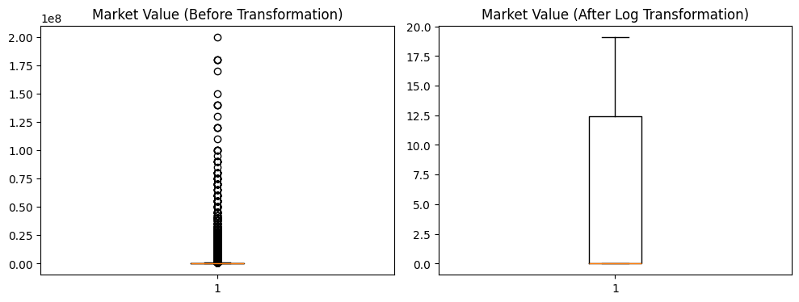
Fig.1. Outlier analysis
Figure 1 compares the distribution of market values before and after logarithmic transformation. The raw distribution exhibits extreme right skewness driven by a small number of elite players. Log transformation compresses the scale, reduces the influence of outliers, and improves numerical stability for regression and ensemble learning models.

4. Feature Consistency and Multicollinearity Checks
Before model training, the feature space was evaluated for consistency and redundancy. Correlation analysis was used to identify highly correlated variables, particularly among rolling statistics, cumulative performance metrics, and derived per-90 features.
While some level of correlation is expected in football performance data, redundant features with minimal additional information were removed to improve generalization. This step ensured a balanced trade-off between model complexity and interpretability.
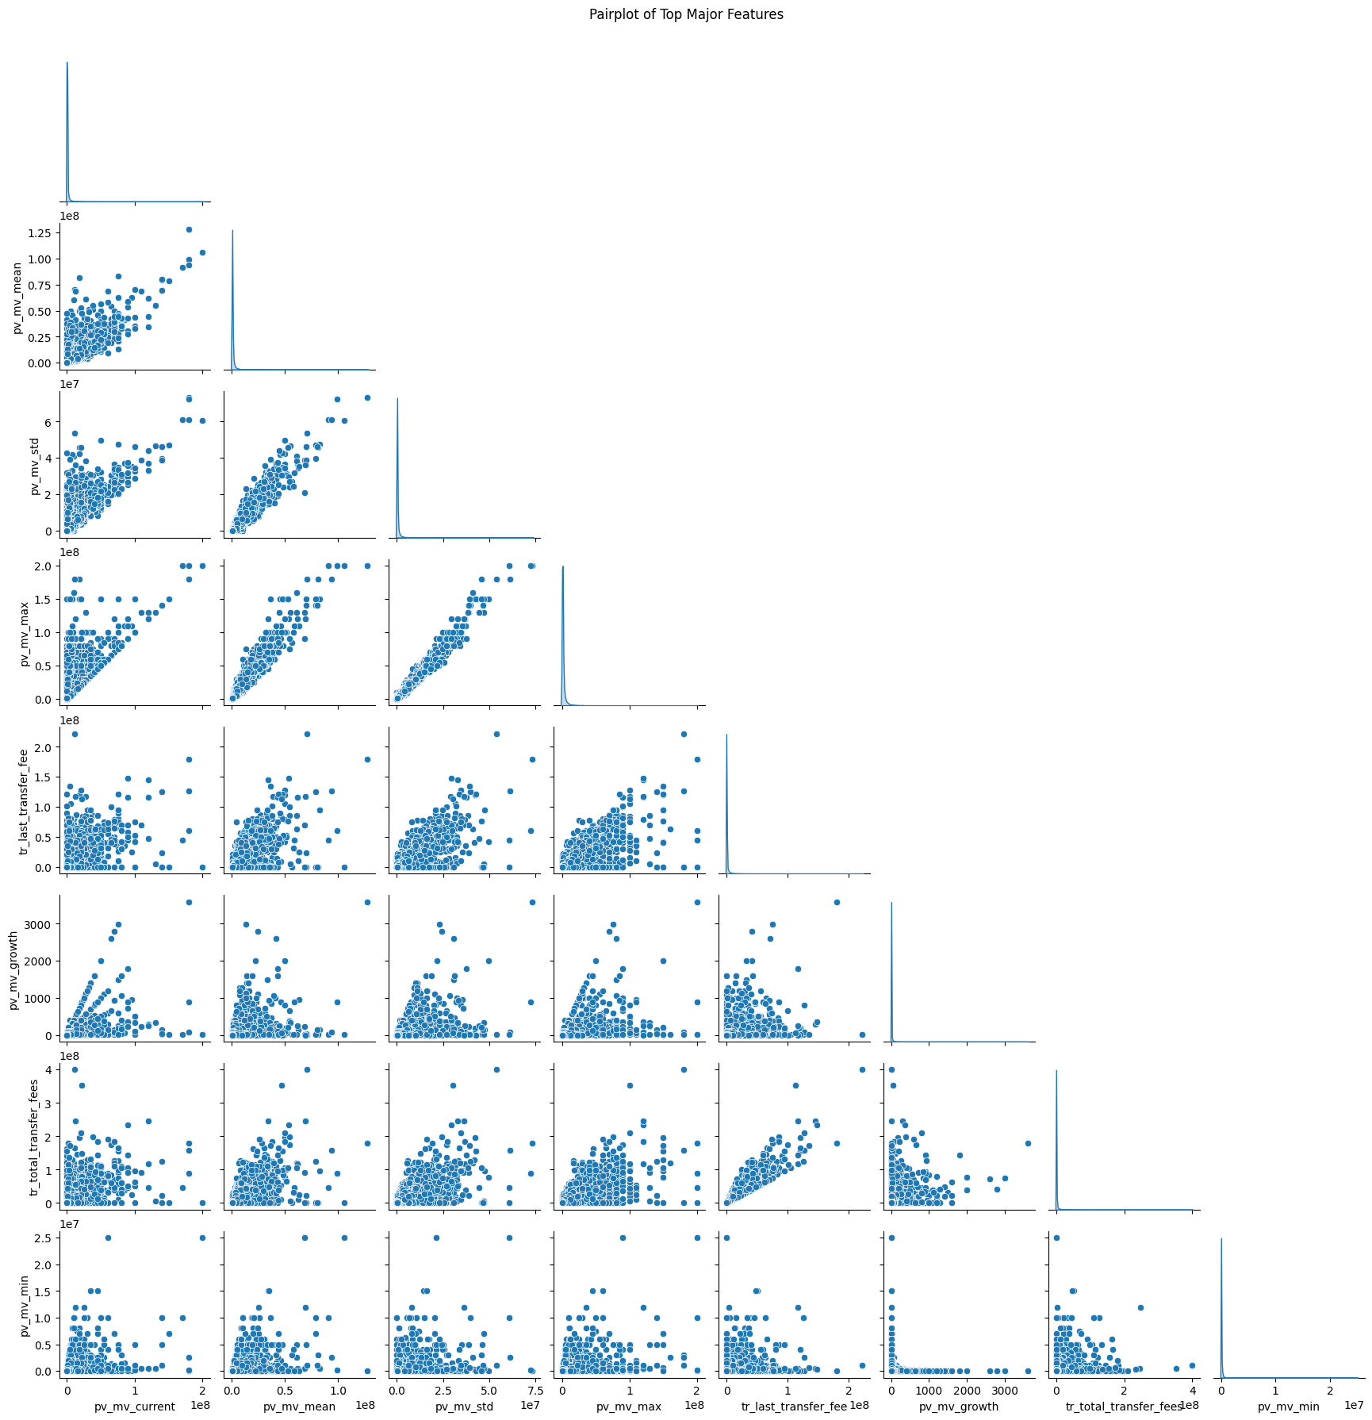
Fig 2. pairwise relationships among major market-value and transfer-related features.

2. Modeling Strategy and Evaluation Framework
A progressive modeling strategy was adopted, starting with simple linear models and gradually advancing toward non-linear ensemble methods. This approach ensured that improvements in predictive performance were empirically justified rather than assumed.
All models were evaluated using:
- Root Mean Squared Error (RMSE)
- Coefficient of Determination (R²)
Performance was measured on both training and validation datasets to explicitly analyze overfitting and generalization behavior. In addition, model behavior was examined using:
- Actual vs Predicted plots
- Residual distribution plots
- Training vs validation error curves
These visualizations played a central role in model selection.

3. Baseline and Regularized Linear Models

3.1 Linear Regression (Baseline Model)
Linear Regression was used as a baseline to establish a reference performance level. While the model captured broad trends in the data, it struggled to represent complex non-linear interactions between performance, transfer, injury, and sentiment features.
Visual inspection of actual versus predicted values revealed systematic deviations for high-value players, while residual plots showed structured patterns rather than random dispersion. This indicated high bias and motivated the need for more expressive models.

3.2 Lasso Regression
To address multicollinearity and reduce model variance, Lasso regression was introduced with L1 regularization. Hyperparameter tuning was performed over a range of regularization strengths to identify the optimal balance between bias and variance.
Compared to the baseline model, Lasso demonstrated improved stability and reduced overfitting. However, visualization-based diagnostics showed that the model still failed to fully capture non-linear valuation dynamics, particularly for elite players. As a result, linear models were retained primarily as benchmarks rather than final candidates.

4. Tree-Based Ensemble Model: Random Forest
Random Forest regression was explored to model non-linear relationships and feature interactions automatically. The ensemble structure significantly improved training performance, highlighting the importance of interaction effects between engineered features.
While Random Forest provided strong predictive power, its generalization stability was inferior to boosting-based approaches.

5. Gradient Boosting Model: LightGBM

5.1 Model Selection Rationale
LightGBM was selected for further experimentation due to its proven effectiveness on structured tabular data, ability to model complex non-linearities, and computational efficiency. Unlike Random Forest, gradient boosting incrementally corrects residual errors, enabling finer control over learning behavior.

5.2 Hyperparameter Tuning
Hyperparameter tuning was conducted to optimize model performance and prevent overfitting. Key parameters tuned included:
- Learning rate
- Number of boosting rounds
- Tree depth and leaf constraints
Model performance was monitored using training and validation RMSE curves, allowing early detection of divergence between training and validation errors. This ensured that model complexity was increased only when it resulted in genuine validation improvement.

5.3 Visual Model Validation
Several plots were used to validate LightGBM behavior:
- Training vs Validation RMSE curves demonstrated stable convergence, with no sharp divergence, indicating controlled learning.
- Actual vs Predicted scatter plots showed strong alignment along the diagonal, confirming accurate predictions across value ranges.
- Residual distributions were centered close to zero with reduced variance compared to other models.
These visual diagnostics collectively confirmed that LightGBM achieved the best balance between accuracy and generalization.

6. Model Evaluation and Diagnostic Analysis
Evaluation results showed that linear models provided strong baseline interpretability but struggled with non-linear feature interactions. Ensemble models demonstrated significantly improved performance, with LightGBM achieving the best balance between accuracy and generalization.
Training and validation error curves were analyzed to verify convergence and detect overfitting. Residual analysis further confirmed that prediction errors were more evenly distributed after incorporating engineered features such as rolling performance metrics, injury risk, and sentiment indicators.
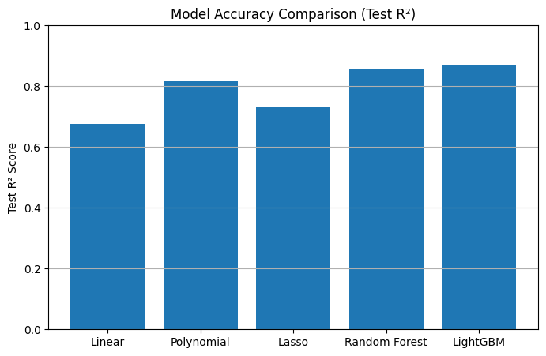
Fig 3. Model Accuracy Comparison
These diagnostics validated the effectiveness of the feature engineering and data preparation steps performed in earlier milestones.

7. Interpretability and Business Alignment
Analysis of feature importance and prediction behavior revealed that the final model effectively integrates:

- Recent performance trends
- Transfer history and market exposure
- Injury-related availability risk
- Contract and age-related economic factors
- Sentiment-based public perception signals
This alignment with real-world valuation drivers increases confidence in the model’s practical relevance and decision-support capability.

Milestone 3 Outcomes
In this milestone, multiple regression models were trained, tuned, and systematically validated using both quantitative metrics and visualization-based diagnostics. Hyperparameter tuning played a critical role in refining model behavior and preventing overfitting.
The LightGBM model emerged as the most reliable predictor due to its superior generalization performance, stable learning dynamics, and strong alignment with football market valuation logic. This validated model forms the foundation for deployment and production readiness, which is addressed in the subsequent milestone.

